Exercise 2
Title: Implementing Dependency Injection in a Library Management Application

✅ Objective

To implement setter-based Dependency Injection using Spring’s IoC container in a simple library management application, where BookService depends on BookRepository.
📁 Project File Structure
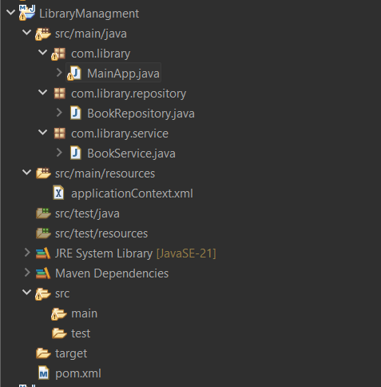

💡 Explanation of Changes
BookService.java
The BookService class contains a setter method for injecting the BookRepository dependency and a method issueBook(String) to simulate issuing a book.
package com.library.service;

import com.library.repository.BookRepository;

public class BookService {
private BookRepository bookRepository;

// Setter
public void setBookRepository(BookRepository bookRepository) {
this.bookRepository = bookRepository;
}

// Business method
public void issueBook(String bookName) {
System.out.println("Issuing book: " + bookName);
bookRepository.save(bookName);
}
}

BookRepository.java
Provides a save() method that prints the book name being saved to simulate storage logic.
package com.library.repository;

public class BookRepository {
public void save(String bookName) {
System.out.println("Saving book: " + bookName);
}
}

applicationContext.xml
Wires the BookService and BookRepository beans using setter injection.

<?xml version="1.0" encoding="UTF-8"?>
<beans xmlns="http://www.springframework.org/schema/beans"
xmlns:xsi="http://www.w3.org/2001/XMLSchema-instance"
xsi:schemaLocation="http://www.springframework.org/schema/beans
http://www.springframework.org/schema/beans/spring-beans.xsd">

<bean id="bookRepository" class="com.library.repository.BookRepository"/>
<bean id="bookService" class="com.library.service.BookService">
<property name="bookRepository" ref="bookRepository"/>
</bean>

</beans>

MainApp.java
Loads the Spring application context, retrieves the bookService bean, and calls issueBook().

package com.library;

import com.library.service.BookService;
import org.springframework.context.ApplicationContext;
import org.springframework.context.support.ClassPathXmlApplicationContext;

public class MainApp {
public static void main(String[] args) {
ApplicationContext context = new ClassPathXmlApplicationContext("applicationContext.xml");
BookService bookService = (BookService) context.getBean("bookService");
bookService.issueBook("Kimestu no Yabi (Manga)");
}
}

🖥️ Output from Console

